Copyright for test papers and marking guides remains with West Australian Test Papers.
The papers may only be reproduced within the purchasing school according to the advertised Conditions of Sale.
Test papers should be withdrawn after use and stored securely in the school until Friday 6th December 2013.



PHYSICS

YEAR 11

2B
2013

Name: _______________________________________________________

Teacher: ___________________________________________________

TIME ALLOWED FOR THIS PAPER

Reading time before commencing work: Ten minutes

Working time for the paper: Three hours

MATERIALS REQUIRED/RECOMMENDED FOR THIS PAPER

To be provided by the supervisor:
- This Question/Answer Booklet; Formula and Constants sheet

To be provided by the candidate:
- Standard items: pens, pencils, eraser or correction fluid, ruler, highlighter.

- Special items: Calculators satisfying the conditions set by the Curriculum Council for this subject.

IMPORTANT NOTE TO CANDIDATES
No other items may be taken into the examination room. It is your responsibility to ensure that you do not have any unauthorised notes or other items of a non-personal nature in the examination room. If you have any unauthorised material with you, hand it to the supervisor before reading any further.

All calculations are to be set out in detail. Marks may be awarded for correct equations and clear setting out, even if you cannot complete the calculation. Express numerical answers to two (2) or three (3) significant figures and include units where appropriate. Express estimates to one (1) or two (2) significant figures, and state any assumptions clearly.

STRUCTURE OF THE PAPER

Section | No. of  Questions | No. of questions  to be attempted | Suggested working time  (minutes) | Marks available | Proportion of  exam total
1: Short Answers | 15 | ALL | 70 | 64 | 40%
2: Problem Solving | 7 | ALL | 90 | 80 | 50%
3: Comprehension and  Interpretation | 1 | ALL | 20 | 16 | 10%

Note: Above refers to 3 hour paper.

INSTRUCTIONS TO CANDIDATES

Write your answers in the spaces provided beneath each question. The value of each question (out of 160) is shown following each question.

The enclosed Physics: Formulae and Constants Sheet may be removed from the booklet and used as required.

Calculators satisfying conditions set by the School Curriculum and Standards Authority may be used to evaluate numerical answers. The calculator cannot be a “graphics” calculator.

Answers to questions involving calculations should be evaluated and given in decimal form. Final answers should be given up to three significant figures and include appropriate units where appropriate. Despite an incorrect final result, credit may be obtained for method and working providing these are clearly and legibly set out.

Questions containing specific instructions to show working should be answered with a complete, logical, clear sequence of reasoning showing how the final answer was arrived at; correct answers which do not show working will not be awarded full marks.

Questions containing the instruction "ESTIMATE" may give insufficient numerical data for their solution. Students should provide appropriate figures to enable an approximate solution to be obtained.
Section 1: Short Answers

Marks allocated: 64 marks out of a total of 160 (40%)
Suggested working time: 70 minutes

Attempt ALL questions in this section. Not all questions attract the same marks.

Answers are to be written in the space below or next to each question.

Question 1 (3 marks)
Answer True or False to each of the following.

(a) When 200.0 g of water is heated from 10 ºC to 50 ºC it has absorbed the same quantity of heat as when it is heated from 60 ºC to 90 ºC. ____________________________

(b) When 200.0 g of water cools from 50 ºC to10 ºC it gives off the same quantity of heat as when it cools from 90 ºC to 50 ºC. _________________________________

(c) When 200.0 g of water is heated from 20 ºC to 60 ºC it has absorbed the same quantity of heat as when lead is heated from 20 ºC to 60 ºC. _____________________________

(specific heat capacity of water is 4.18 x 10³ J kg⁻¹ K⁻¹ and the

specific heat capacity of lead is 1.28 x 10² J kg⁻¹ K⁻¹ )
(3 marks)

Question 2 (4 marks)
A tray containing 700.0 mL of water at 20.0 ºC is placed in the freezer compartment of a refrigerator. How much heat must be removed from the water for it to become ice at -4.0 ºC?
(4 marks)

Question 3 (3 marks)
Name a safety feature in modern houses that limits the risk of receiving an electric shock and describe how it works. (3 marks)

Question 4 (3 marks)
A 4 L sealed can is half full of petrol. In terms of the kinetic theory of matter, describe in detail the behaviour of the molecules of petrol in the can.
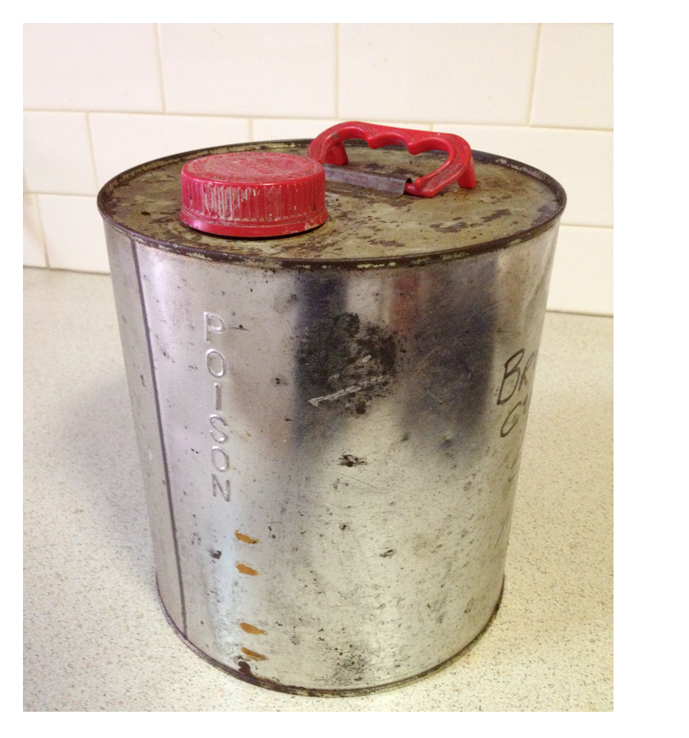
(3 marks)

Question 5 (4 marks)
The average power applied by an adult’s heart for circulating of blood in the body is about
1.5 W.
(a) How much work does an adult human heart do in an hour? (2 marks)

(b) If the adult described in (a) runs for 4 hours, would you expect the work done by the heart to be 4 times greater? Support your answer with sound reasoning. (2 marks)

Question 6 (4 marks)

For the following voltmeters read the scale, record the value on the scale, including units, and determine the uncertainty of the measurement. (4 marks)

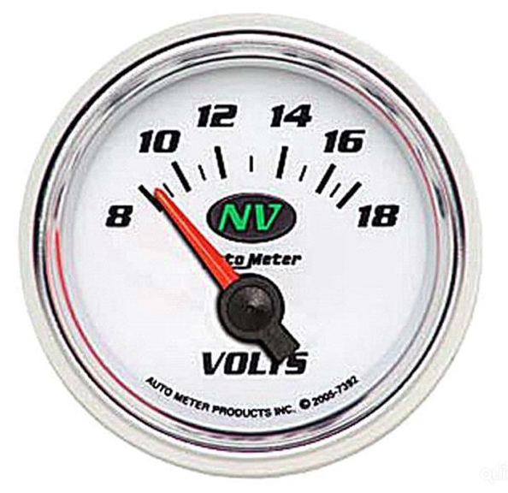
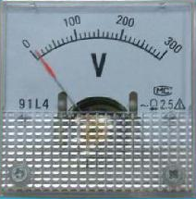
(a) Record the measurement __________ (b) Record the measurement _________

Record the uncertainty ___________ Record the uncertainty _________

Question 7 (4 marks)

The cathode ray tube in a television set accelerates electrons form rest through a potential difference of 120.0 kV.
(a) How much energy, in joules, does each electron gain in being accelerated in this field? (2 marks)

(b) If the energy gained by each electron is 98% kinetic, calculate the velocity the electron will have after undergoing this acceleration? (2 marks)

Question 8 (3 marks)
A shop assistant opens a bottle of perfume to demonstrate the fragrance to a customer. Within a few seconds the smell of the perfume can be detected by another shopper who is standing several metres away. Using your understanding of the kinetic molecular theory, explain why the perfume can be detected several metres from the open bottle. (3 marks)

Question 9 (4 marks)
When it is not convenient to connect your iPad to the mains to recharge it, a portable charger (see opposite), can be used. A typical portable charger can deliver 3.0 V with a current of 1.9 A.
(a) If the device is connected to the iPad for 2.5 hours, how much charge flows from the power charger to the iPad in that time? (2 marks)

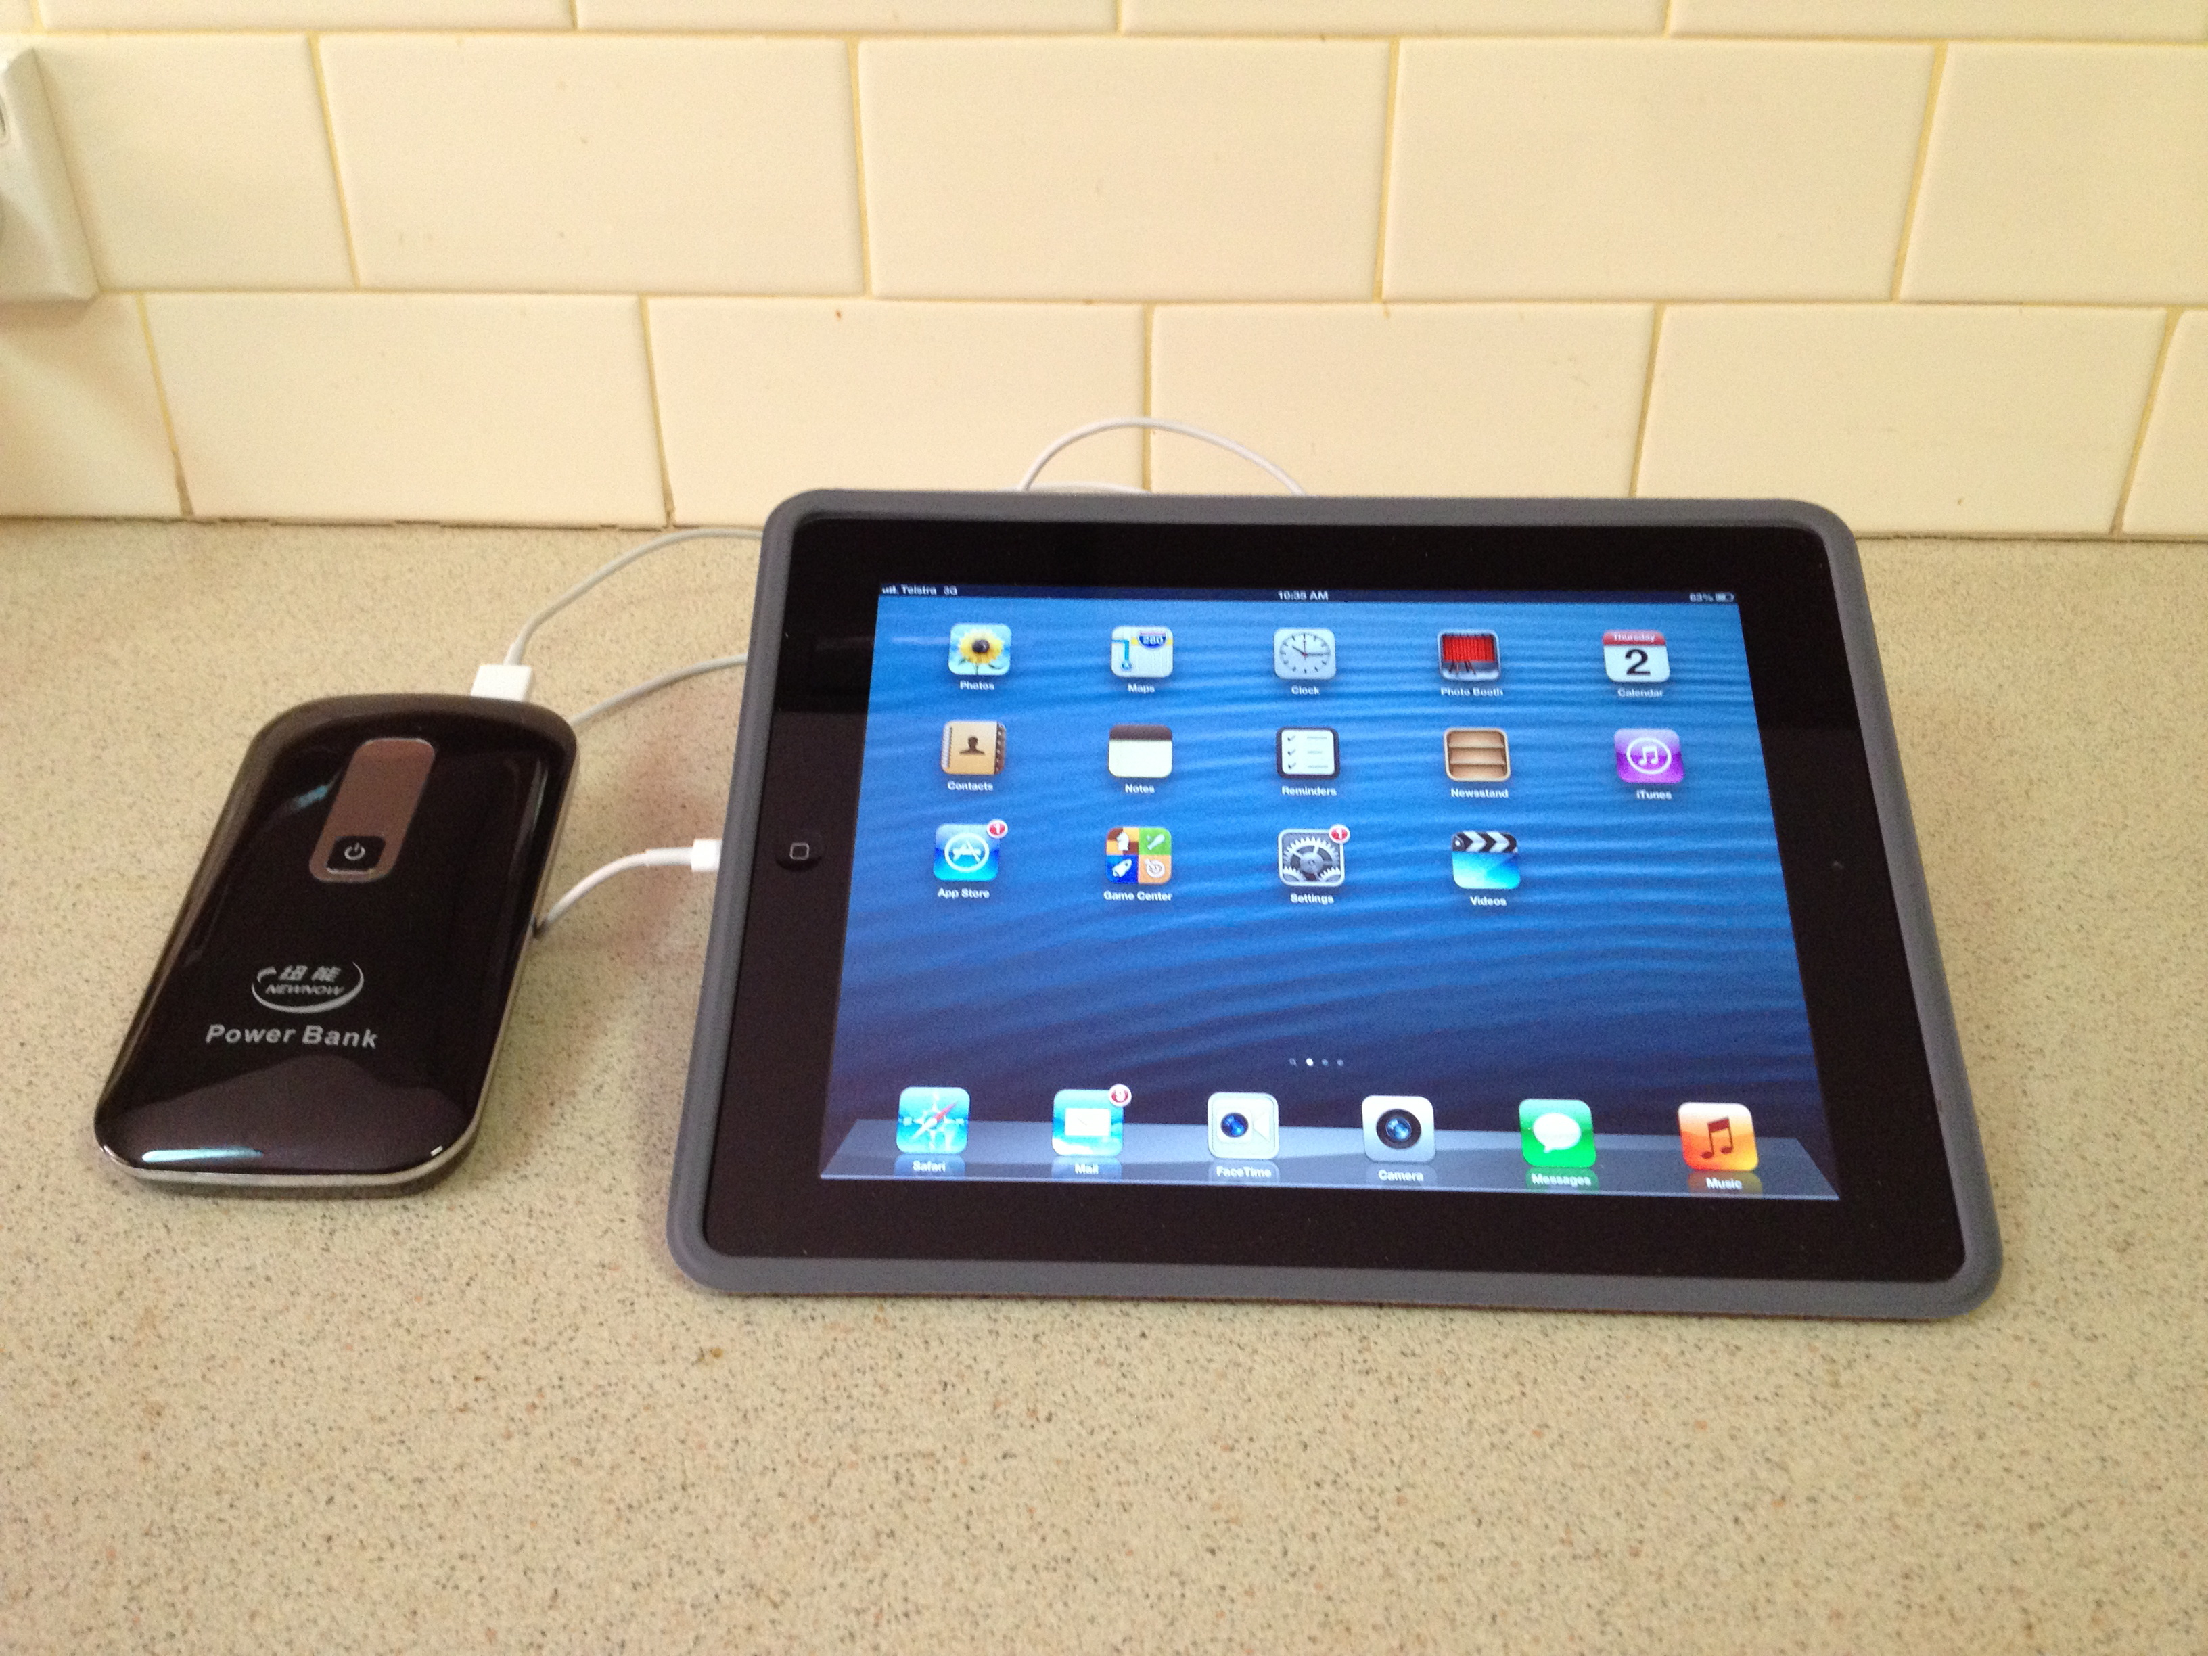

(b) How much work is done in moving the charge? (2 marks)

Question 10 (3 marks)
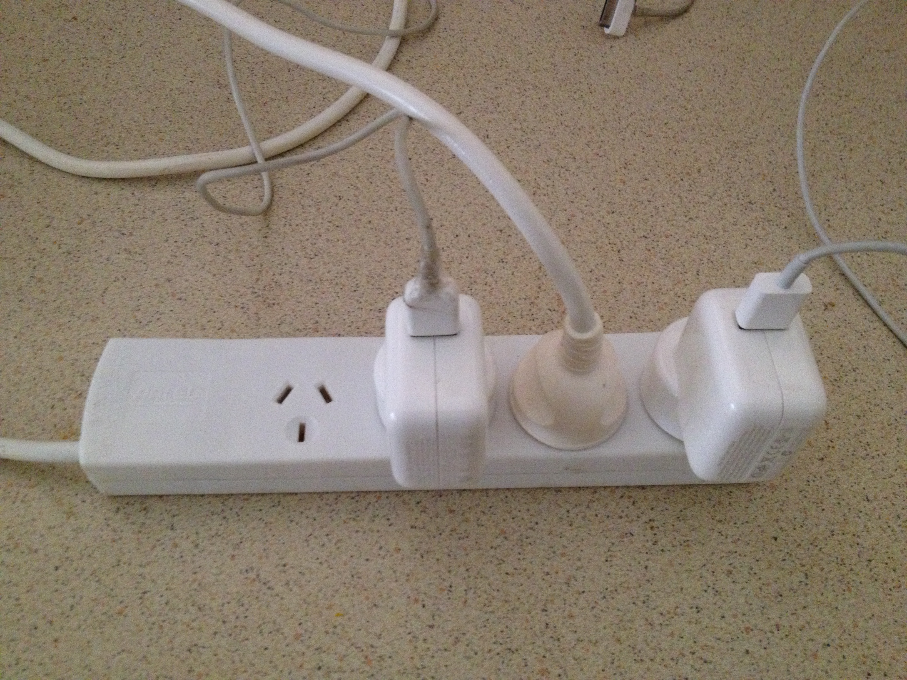
A four outlet power board (see photo opposite) used to connect a computer, printer and desk lamp to a single 240 V outlet, is rated for a maximum current of 8.00 A. Why shouldn’t a portable electric heater, rated at 240 V and 2.50 kW, be plugged into the fourth outlet on the power board? Explain, and support your answer with calculations. (3 marks)

Question 11 (4 marks)
Below is a diagram of two charged particles.
(a) On the diagram draw arrows to show the position and direction of the electric field associated with the two charges. (2 marks)

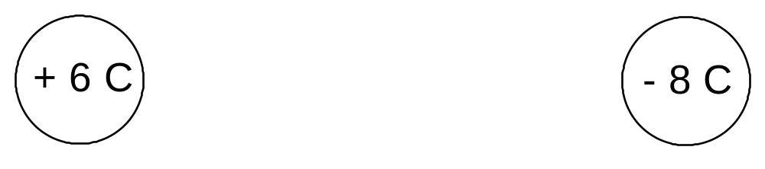

(b) If the charges are separated by a few millimetres and are free to move, predict what movement, if any, will occur? (1 mark)

(c) Explain your answer to (b) above. (1 mark)

Question 12 (6 marks)

When a person touched the door handle of a car that had just been driven, they received a small electric shock.
(a) Describe the most likely conditions that contribute to the person receiving the shock. (2 marks)

(b) When a second person touched the handle they did NOT receive a shock. Suggest a reason why the second person did not receive a shock? (2 marks)

(c) Car tyres are impregnated with carbon. How does this reduce the likelihood that people will receive shocks when touching car door handles? (2 marks)

Question 13 (4 marks)

Below is a diagram of a simple thermostat that will activate an alarm when the surrounding area is heated dangerously as in a fire. The bimetallic strip consists of two identical strips of different metals, riveted together.
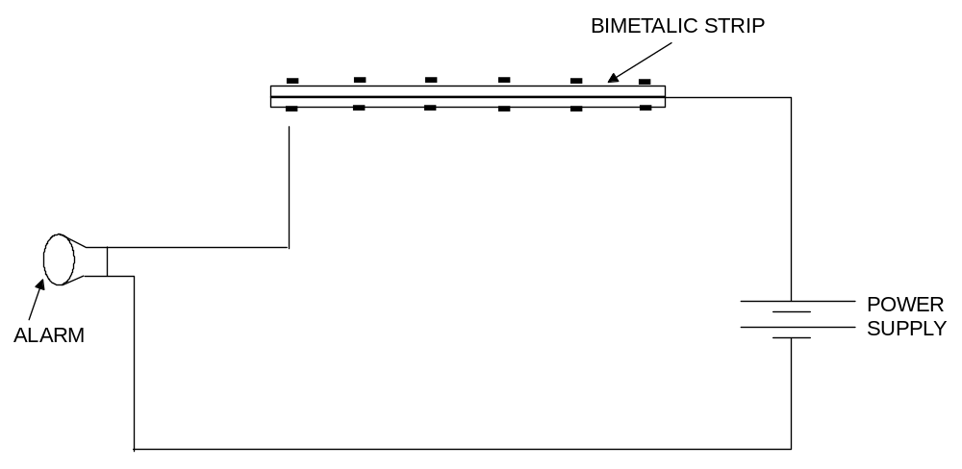

Explain the physics principles involved in this fire alarm (4 marks)

Question 14 (7 marks)

A fast moving cricket ball hits the edge of a stationary bat transferring 18.1 J of energy to the bat.
(a) Describe in terms of the kinetic theory of matter how this transfer of energy occurs. (3 marks)

(b) The ‘hot spot’ image of the collision taken at the instant of impact shows that about
4.0 g of bat wood absorbs the 18.1 J of energy and increases the temperature of that portion of the bat. Estimate the temperature increase of that portion of the bat. (4 marks)
(The specific heat capacity of the bat wood is 2.25 x 10³ J kg⁻¹ K⁻¹ )

Question 15 (8 marks)

(a) The most common way of keeping warm in bed during cold nights is to cover ourselves with blankets. Explain briefly how blankets keep us warm by referring to the three (3) methods of heat transfer.

(i) Conduction (2 marks)

(ii) Convection (2 marks)

(iii) Radiation (2 marks)

(b) In some cases people prefer a doona instead of blankets to keep warm. (A doona is an envelope of fabric filled with either feathers or fibre). Describe in terms of heat transfer the major advantage of a doona compared to blankets. (2 marks)

END OF SECTION 1

Section 2: Problem Solving

Marks allotted: 80 marks out of a total of 160 (50%)
This section contains 7 questions. Suggested working time 90 minutes

Answer the questions in the spaces provided.

Question 16 (13 marks)
The diagram below represents an electric circuit that has been set up to demonstrate various electrical concepts. The globes are identical in every way and each has a resistance of 20.0 Ω and a power rating of 2.0 W. The power supply is set on 12.0 V. The circle “X” represents a meter.

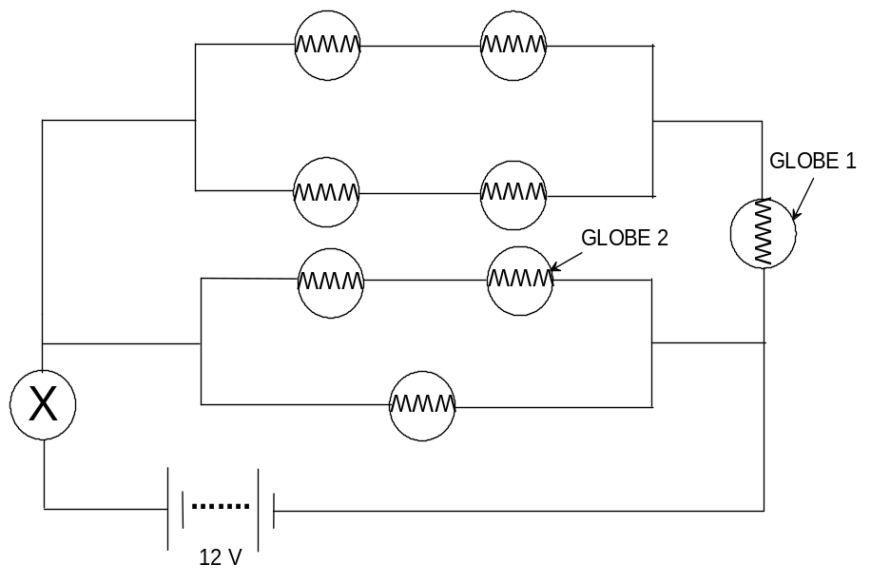

(a) Calculate the total resistance in the circuit. (Ignore the internal resistance of the meter and the power supply) (5 marks)

(b) What is the reading on the meter labelled X. (include units)? (3 marks)

(c) Is the current flowing through globe 1:

(A) equal to,

(B) less than or

(C) more than,

the current flowing through globe 2? Support your answer with appropriate calculations. (3 marks)

(d) Is globe 1 operating at its maximum power output? Support your answer with appropriate calculations. (2 marks)

Question 17 (13 marks)
Below is a circuit diagram showing how meters could be connected into an electrical system to measure current and voltage (potential difference). Not all of the meters have been correctly connected.

(a) Examine the circuit diagram and complete the table below by placing ‘yes’ or ‘no’ in the second column. (2 marks)
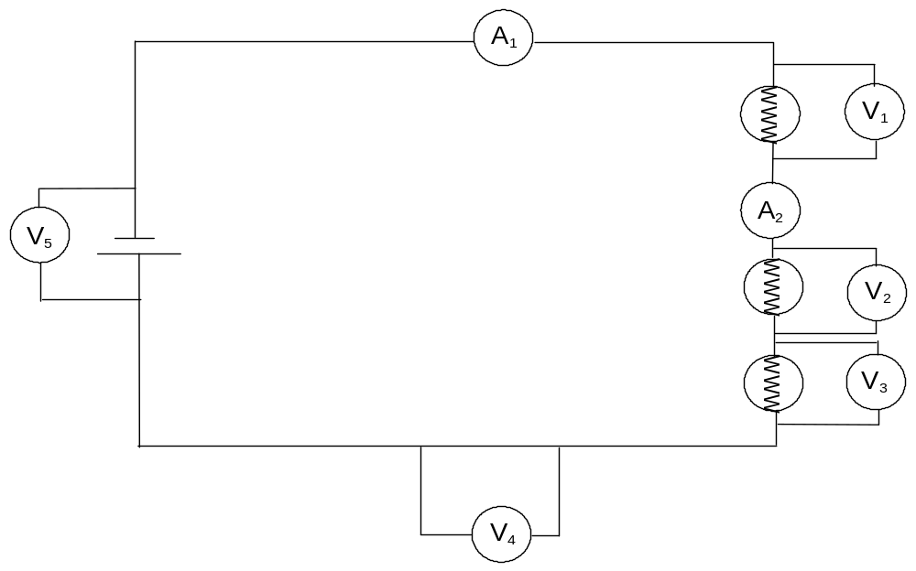

Meter | Is it correctly connected?
Voltmeter 1 (V₁)
Voltmeter 2 (V₂)
Voltmeter 3 (V₃)
Voltmeter 4 (V₄)
Voltmeter 5 (V₅)
Ammeter 1 (A₁)
Ammeter 2 (A₂)

(b) If all the globes in the circuit have identical resistances of 30.0 Ω and the power source is a 9.0 V battery then determine the following:

(i) the total resistance in the circuit. (2 marks)

(ii) the total current in the circuit. (2 marks)

(iii) the reading on ammeter 1 (A₁). (1 mark)

(iv) the reading on ammeter 2 (A₂). (1 mark)

(v) the reading on voltmeter 1 (V₁). (2 marks)

(vi) the reading on voltmeter 5 (V₅). (1 mark)

(c) Explain why you would expect the reading on voltmeter 4 (V₄) to be zero. (2 marks)

Question 18 (12 marks)

In an experiment to demonstrate how efficiently electrical energy is transformed into heat energy, a student set up an electrical circuit containing a nichrome wire heating coil immersed in a glass beaker of water. The circuit was switched on and the time to bring the water to its boiling point was recorded. A diagram of the circuit appears below.

Data collected from the experiment:
Mass of water = 100.0 g
Initial temperature of the water = 21.0 ºC
Time for water to reach boiling point = 20.0 min
Steady reading on the voltmeter = 12.0 V
Steady reading on the ammeter = 2.5 A
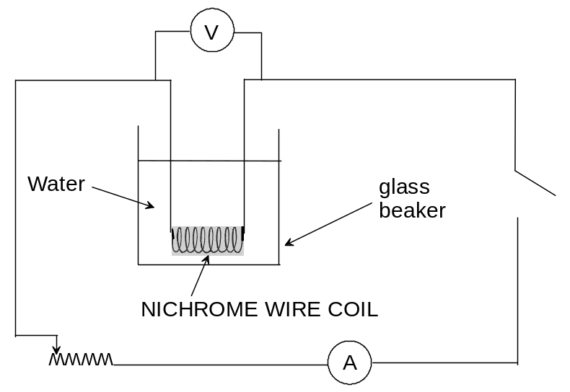

(a) Calculate the quantity of electrical energy produced by the circuit. (3 marks)

(b) Calculate the quantity of heat energy absorbed by the water. (3marks)

(c) Calculate the efficiency of the system by comparing the measured energy input with the measured energy output. (3 marks)

(d) Explain why the efficiency is not 100%. (2 marks)

(e) Suggest one improvement that could be made to increase the efficiency of the system. (1 mark)

Question 19 (11 marks)
An aging, domestic hot water system containing 150.0 L of water is turned off while the occupants of the house go on holidays. Upon returning, the 240 V system is turned on and the water begins to heat.
(a) If the water was at 22.0 ºC, calculate the quantity of energy that must be transferred to the water to raise the temperature to 78.0 ºC. (2 marks)

(b) Calculate the time this will take if the electric heating element in the tank is rated at
6.00 kW and is operating at its rated power output. (3 marks)

(c) In fact it takes a little longer for the water to reach 78 ºC. Suggest a reason for the increase in time. (1 mark)

(d) If the heater operates at its rated power output and each unit (kWh) of electricity costs
22.6 cents, how much would it cost to heat the water from 22.0 ºC to 78.0 ºC? (2 marks)

(e) Calculate the resistance in the heating element that allows the heater to operate at its rated power output. (2 marks)

(f) In fact the aging heater does not operate at its maximum power output. The maximum current it draws is 8.00 A. Calculate the power output of the heating element when it is connected to the mains. (1 mark)

Question 20 (11 marks)
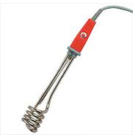
Students were given the task of verifying the stated power rating of an electric immersion heater. They decided to use various masses of naphthalene which were heated independently and the time taken for the heater to melt each sample was recorded. In each case the sample was placed in a calorimeter, together with the immersion heater and heated until the naphthalene melted.
Note: The latent heat of fusion (L_{f}) of naphthalene is 1.48 x 10⁵ J kg⁻¹
immersion heater
The results are recorded in the table below:

Mass of naphthalene (kg) | Time to melt (s)
0.250 | 470
0.350 | 680
0.450 | 860
0.550 | 1050
0.650 | 1260

The data was considered in terms of the relationship between power, mass, latent heat of fusion
and time.
A graph was then drawn to produce a gradient which was used to calculate the actual power output of the heater.

(a) Plot the data on the grid below. Clearly label the graph. (3 marks)


(b) Determine the gradient of the plotted data. Show working and units (2 marks)

(c) Use the gradient and the mathematical relationship between power, mass, latent heat of fusion and time to calculate the power output of the immersion heater. Show all your reasoning and working including the correct units. (4 marks)

(d) Would you expect the calculated power rating of the heater to be higher or lower than the true power rating? Explain your answer. (2 marks)

Question 21 (12 marks)
Some students conducted an experiment to determine the latent heat of fusion of ice.
They followed the method below
- Warm water was placed into a copper calorimeter and the temperature recorded.
- An ice cube at 0.00 °C was dried with a paper towel.
- The ice cube was placed in the warm water in the calorimeter and the final temperature was recorded when the melted ice, the water and the calorimeter had reached thermal equilibrium.
- Results were recorded in the table below.

Table of results:

Measurement | Data
Mass of copper calorimeter | 73.0 g
Mass of calorimeter + warm water | 159 g
Mass of calorimeter + warm water + ice | 193 g
Mass of warm water
Mass of ice
Initial temperature calorimeter + warm water | 41.6 °C
Final temperature calorimeter + warm water + melted ice | 9.00 °C
Temperature change calorimeter + warm water
Initial temperature of ice | 0.00 °C
Temperature change of melted ice (water) in calorimeter

(a) Complete the table by filling in the blanks. (Some of the values have been done for you.) (4 marks)

(b) Use this data to calculate the latent heat of fusion of ice in this experiment. (8 marks)

      - The specific heat capacity for copper is 3.80 x 10² J kg⁻¹ K⁻¹

Question 22 (8 marks)
(a) Resistors can be either ohmic or non-ohmic. Describe in terms of resistance how they differ from each other. (2 marks)

(b) An ohmic resistor labelled 5.0 W is in an electrical circuit where the potential difference can vary from 1.0 V to 100.0 V.
(i) Calculate the range of current that will flow in it. (2 marks)

(ii) Calculate the energy that will be dissipated in the resistor each second when a current of 5.0 A is flowing through it. (2 marks)

(iii) What factors determine how much power is dissipated in the ohmic resistor? (2 marks)

Section 3: Comprehension (Marks allocated: 16 marks out of 160 (10%)

Suggested working time 20 minutes
This section has one (1) question. You must answer this question. Write your answer in the spaces provided.
When estimating numerical answers, show your working or reasoning clearly. Include units where appropriate.

Question 23
Cycling is good for the environment and your health but sometimes you may need a little help. That is the reason there has been an increase in the sale of electric bicycles, particularly to more elderly people. An electric bicycle, also known as an e-bike, is a bicycle with an integrated electric motor that can be used for propulsion. There is a great variety of different types of e-bikes available in Australia, from e-bikes that only have a small motor to assist the rider's pedal-power (i.e. pedelecs) to somewhat more powerful e-bikes which tend closer to motor bike style functionality.
All however retain the ability to be pedalled by the rider and are therefore not electric motorcycles. E-bikes use rechargeable batteries and the lighter models can travel up to 25 - 32 km /h, depending on the laws of the country in which they are sold, while the more high-powered model can often travel a lot faster.
The e-bikes typically have a 200 W motor powered by a 36 V, 10 Amp hour (Ah) lithium ion battery pack that can be recharged from 240 V mains supply using a transformer.
The distance they can travel on a fully charged battery depends on whether you use the ‘pedal assist’ function. That means you can extend the range by pedaling at the same time as using the electric motor.

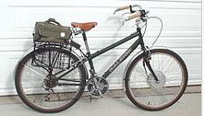
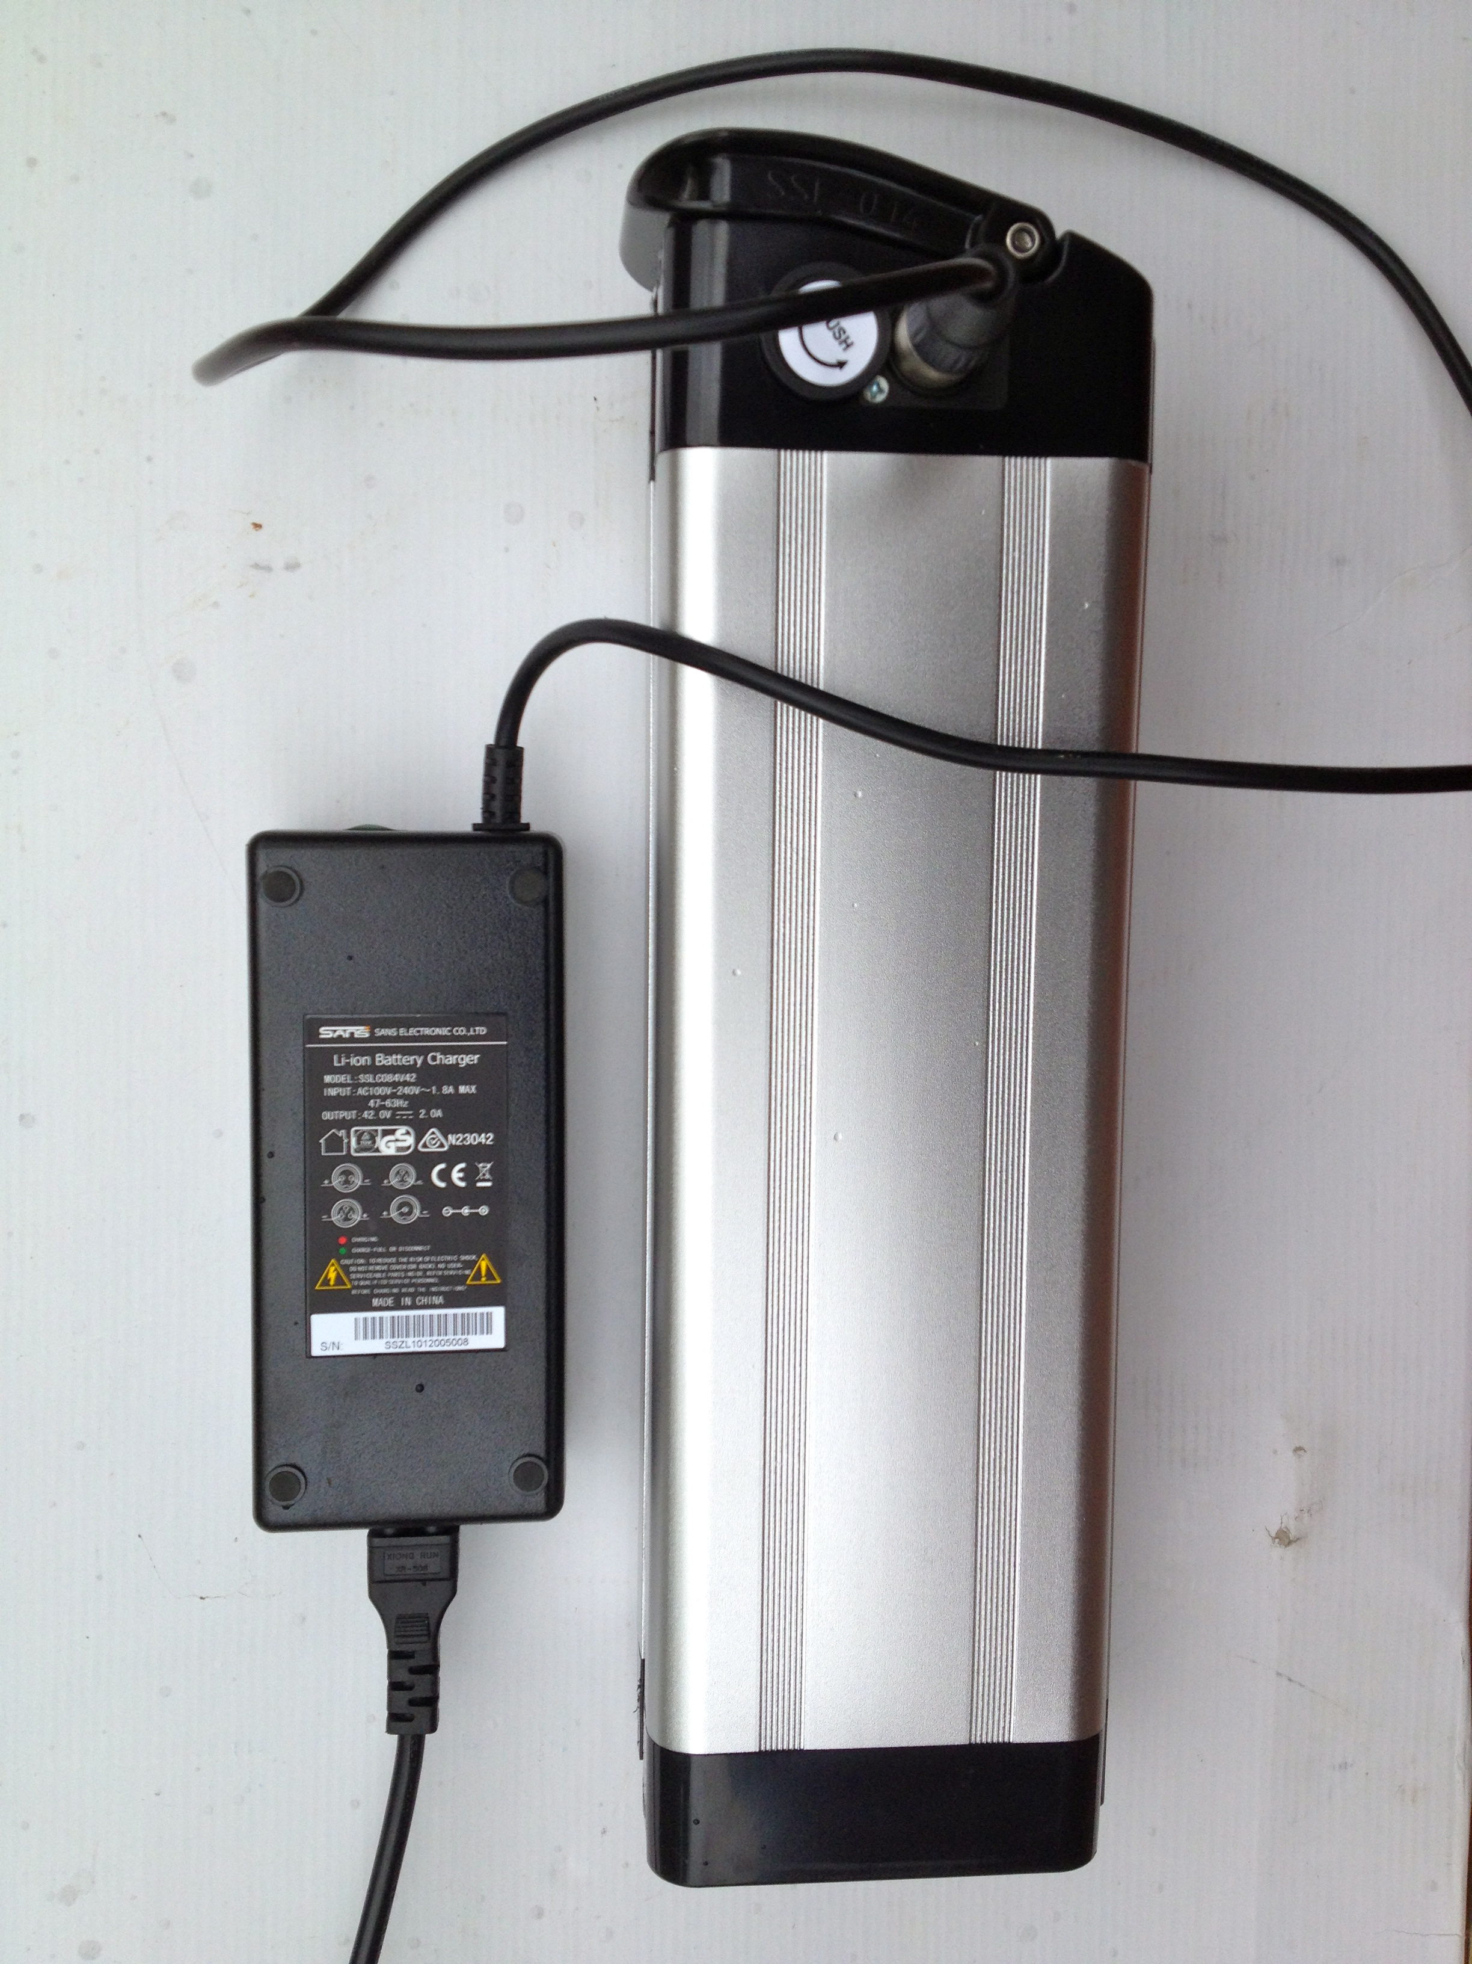

Travelling on a flat, sealed road surface the battery will take you about 60 km without pedaling. If on the other hand you use the pedal assist function the range can be extended to 100 km. Compared to a carbon frame racing bike at about 7.0 kg, the typical e-bike, at 25 kg is not the lightest option to pedal. However, the mass disadvantage is compensated for by ease of operation.
An integrated computer attached to the handlebars conveys information to the rider about distance travelled, speed, battery charge and projected range. Using this data the rider can make decisions about how likely they will be able to reach their destination!!
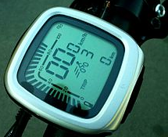

Questions
(a) In what way are e-bikes ‘good for the
environment’? (2 marks)

(b) In what way are e-bikes ‘good for your health’? (2 marks)

(c) If the e-bike’s 200 W electric motor is working at its stated power, calculate the current it would be drawing from the lithium ion battery. (2 marks)

(d) Amp hours (Ah), when applied to batteries, provides an approximate indication of how long a battery is capable of delivering a particular current (A). For instance a battery rated at 10 Ah could deliver 5A for 2 hours when connected to an appliance. If the typical e-bike described in this article, draws 3A on a ride, calculate how long the battery will deliver enough power to propel the bike. (2 marks)

(e) Explain what would happen to the power output of the motor when the rider was using the pedal assist function and how would this change the distance the rider could travel. (1 mark)

(f) Explain how the current delivered to the motor would change when pedal assist was engaged. (1 mark)

(g) After a ride the cyclist discovers the battery is completely discharged. If the battery is connected to a 36 V charger that delivers a steady current of 2.0 A to the battery for
2 hours on same line, calculate the quantity of charge that is delivered to the battery.
(2 marks)

(h) Estimate the electrical resistance in the e-bike electrical system when the
200 W motor is being driven by its 10 Ah e-bike battery. (2 marks)

(i) Calculate the energy output of the battery if it delivers an average of 3.0 A on a 3.0 hour ride. (2 marks)

END OF EXAMINATION

